**A**

**PROJECT REPORT**

**on**

**AI DRIVEN AGRIBOT**

SUBMITTED TO AN AUTONOMOUS INSTITUTE, AFFILIATED TO SAVITRIBAI PHULE PUNE UNIVERSITY, PUNE IN THE PARTIAL FULFILLMENT OF THE REQUIREMENTS

FOR THE AWARD OF THE DEGREE

**BACHELOR OF TECHNOLOGY**

**in**

**(****Electronics & Telecommunication Engineering)**

## SUBMITTED BY

VAIBHAV NRUPNARAYAN Reg. No :2021AETN1101136

ABHIMAN BADE Reg. No :2021AETN1101076

HARISH BAGUL Reg. No :2021AETN1111122

Under the Guidance of

**DR. KAVITA JOSHI**



**DEPARTMENT OF ELECTRONICS & TELECOMMUNICATION ENGINEERING**

**G H RAISONI COLLEGE OF ENGINEERING AND MANAGEMENT WAGHOLI, PUNE 412207**

**AY: 2024-25**

**(Winter 2024)**



# CERTIFICATE

# This is to certify that the project report entitled

“**AI DRIVEN AGRIBOT**”

# Submitted by

**VAIBHAV NRUPNARAYAN Reg. No :2021AETN1101136**

**ABHIMAN BADE Reg. No :2021AETN1101076**

**HARISH BAGUL Reg. No :2021AETN1111122**

are a Bonafide students of this institute and the work has been carried out by them under the supervision of **Dr. Kavita Joshi** and it is approved for the partial fulfillment of the requirement of an Autonomous Institute, Affiliated to Savitribai Phule Pune University, for the award of the degree of **Bachelor of Technology in Electronics & Telecommunication Engineering in** the academic year 2024-25**.**

**(Dr. Kavita Joshi) (Dr. S. K. Waghmare)**

Guide H.O.D.

(……………………….**) (Dr. R. D. Kharadkar)**

**External Examiner** Director

GHRCEM, Pune

**Date:**

**Place:** Pune



|  |
| --- |
| DECLARATION BY THE STUDENT(S) |

We declare that the project entitled "**AI DRIVEN AGRIBOT**” submitted by us for the award of degree Bachelor of Technology in Electronics & Telecommunication Engineering is the record of work carried out by during the period from *June 2024* to *November 2024* under the guidance of **Dr. Kavita Joshi** and has not formed the basis for the award of any degree, diploma, associate ship, fellowship, titles in this or any other University or other institution of higher learning.

We further declare that the material obtained from other sources has been, duly acknowledged in the thesis.

**VAIBHAV NRUPNARAYAN Reg. No :2021AETN1101136**

**ABHIMAN BADE Reg. No :2021AETN1101076**

**HARISH BAGUL Reg. No :2021AETN1111122**

Date: / /

Place: Pune

# ACKNOWLEDGMENT

It gives us great pleasure in presenting **AI DRIVEN AGRIBOT** as our B.Tech. project. Words have never seemed as inadequate as now when we are endeavoring to express our gratitude at the culmination of our B.Tech. Project to all those who have made it possible. Even the best efforts are waste, without the proper guidance and advice of our project guide **Dr. Kavita Joshi** for the consistent guidance, co-operation, inspiration, practical approach, and constructive criticism, which provided us the much-needed impetus to work hard & also thanks **Dr. S. K. Waghmare** Head of E&TC Department for their continuous support & valuable suggestions.

We take this opportunity to thank our Campus Director **Dr. R. D. Kharadkar** for their whole hearted support, motivation & valuable suggestions.

We would also like to thank **Dr. S. D. Hanwate** Project Coordinator for her valuable support in providing us with the required information.

At the end, we would like to give special thanks to all staff members from **E&TC Department** of G H Raisoni College of Engineering and Management, Pune & our colleagues for their kind support & timely suggestions.

**VAIBHAV NRUPNARAYAN Reg. No :2021AETN1101136**

**ABHIMAN BADE Reg. No :2021AETN1101076**

**HARISH BAGUL Reg. No :2021AETN1111122**

**ABSTRACT**

The AI-driven Agribot project presents an innovative solution to modernize rice farming by integrating Machine Learning (ML) and Internet of Things (IoT) technologies to automate rice planting, environmental monitoring, and crop management. Traditional rice cultivation is labor-intensive, time-consuming, and prone to inefficiencies, resulting in higher costs, inconsistent planting, and reduced yields. The Agribot is designed to address these challenges by precisely planting rice seedlings, monitoring plant growth, and evaluating crop health using advanced image processing techniques. By continuously collecting real-time data on plant conditions through sensors, the system enables data-driven decision-making to optimize resource use, improve crop quality, and enhance yields.

AI-driven algorithms allow the Agribot to make intelligent decisions, such as detecting and responding to environmental changes, identifying plant diseases, and managing weeds, thereby improving overall farm management. The system reduces reliance on manual labour, increases planting accuracy, and enhances productivity, making farming more efficient and profitable. This project holds the potential to transform agricultural practices by fostering precision farming techniques, ultimately contributing to food security and sustainable agricultural development. By modernizing rice farming, the AI-driven Agribot can lead to significant advancements in crop production, benefiting both farmers and the agricultural industry.

**Keywords: - Crop disease detection, Rice crop plantation, Machine Learning, Hardware- Raspberry Pi, Ultrasonic Sensor, Camera.**

# TABLE OF CONTENTS

|  |  |  |  |
| --- | --- | --- | --- |
|  | | | **Page No.** |
| **CERTIFICATE** | | | **II** |
| **DECLARATION BY THE STUDENT(S)** | | | **III** |
| ACKNOWLEDGMENT | | | **IV** |
| ABSTRACT | | | **V** |
| **TABLE OF CONTENT**  **LIST OF FIGURES** | | | **VI VIII** |
| LIST OF TABLES | | | **IX** |
| LIST OF ABBREVIATION | | | **X** |
|  | | |  |
| **Sr. No.** | | **Title of Chapter** | **Page No.** |
| **01** | | **Introduction** | 01 |
|  | 1.1 | Introduction | 01 |
|  | 1.2 | Motivation | 03 |
|  | 1.3 | Objectives | 03 |
|  | 1.4 | Project Scope | 04 |
| **02** | | **Literature Survey** | 05 |
| **03** | | **Methodology** | 16 |
|  | 3.1 | Research and Development Framework | 16 |
|  | 3.2 | Data Collection | 18 |
|  | 3.3 | Tools and Technologies Used | 19 |
|  | 3.4 | Validation and Testing Methods | 19 |
|  |  |  |  |
| **04** | | **Project Design and Implementation** | 21 |
|  | 4.1 | System Design | 21 |
|  | 4.2 | System Architecture | 22 |
|  | 4.3 | Process Flow | 24 |
|  | 4.4 | Key Components / Module | 28 |
|  | 4.5 | Challenges and Solutions | 32 |
| **05** | | **Result and Observation** | 33 |
|  | 5.1 | Data and Results | 33 |
|  | 5.2 | Screen Shots | 36 |
|  | 5.3 | Interpretation of Results | 38 |
|  | 5.4 | **Co**mparison with Existing Solutions and Approaches | 39 |
|  | 5.5 | Limitations and Constraints | 39 |
| **06** | | **Conclusion and Scope for the Future** | 41 |
|  | 6.1 | Conclusions | 41 |
|  | 6.2 | Future Work | 42 |
|  |  |  |  |

|  |  |
| --- | --- |
| **Bibliography** | 44 |
| **Appendix I** | 46 |
| **Datasheets** | 48 |
| **Software Program** | 54 |
| **Hardware Program** | 57 |
|  |  |

**LIST OF FIGURES**

|  |  |  |
| --- | --- | --- |
| FIGURE  NO | **ILLUSTRATION** | PAGE  NO |
| 1 | Photo taken during farm visit | 17 |
| 1.1 | Project System Architecture | 23 |
| 2 | Rice Planter Process | 24 |
| 3 | Object detection process | 25 |
| 4 | Circuit diagram for Motor Driver | 26 |
| 5 | Leaf Disease detection | 28 |
| 6 | Raspberry Pi 4 Model B | 24 |
| 7 | GPIO Pin Diagram of raspberry PI | 28 |
| 8.1 | Raspberry Pi Camera Module | 25 |
| 8.2 | DC motor | 26 |
| 8.3 | Servo Motor | 30 |
| 8.4 | Arduino Nano | 30 |
| 8.5 | Motor Driver L293D | 30 |
| 10 | Ultrasonic Sensor (HC-SR04) | 31 |
| 11 | Lithium-Ion Battery | 31 |
| 12 | Plant health monitoring using Raspberry Pi | 35 |
| 13 | Screenshot of the Plant health checking | 36 |
| 14 | VNC software of Remote Control | 37 |
| 15 | Raspberry Pi Interface for Quality Check operation | 37 |
| 16 | AI Driven Agribot Prototype | 38 |
|  |  |  |
|  |  |  |

# LIST OF TABLES

|  |  |  |
| --- | --- | --- |
| **TABLE No.** | **ILLUSTRATION** | **PAGE NO.** |
| 1 | Literature Review Summery | 12 |
|  |  |  |

# LIST OF ABBREVIATION

|  |  |
| --- | --- |
| **ABBREVIATIONS** | **ILLUSTRATIONS** |
| CNN | Convolutional Neural Network |
| IoT | Internet of Things |
| ML | Machine Learning |
| MAE | Mean Absolute Error |
| MSE | Mean Squared Error |
| SVM | Support Vector Machine |
| ANN | Artificial Neural Network |
| R² | Coefficient of Determination |
| RGB | Red Green Blue |
| HSV | Hue Saturation Value |
| CSV | Comma-Separated Values |

**CHAPTER-1 INTRODUCTION**

* 1. **Introduction**

Agriculture is an essential pillar of the global economy, feeding billions and sustaining livelihoods, with rice serving as a staple crop for over half the world's population. Yet, the sector faces significant challenges, particularly in rice farming, where traditional practices rely heavily on manual labor. These methods are labor-intensive, time-consuming, and prone to inconsistencies, leading to suboptimal yields and inefficient resource use. Additionally, the lack of early detection systems for crop health problems results in avoidable losses and a lower overall quality of produce.

With the rise in global food demand and labor shortages, there is an urgent need for innovation in farming techniques to ensure productivity, sustainability, and scalability. This is where the **AI-Driven Agribot** comes in—a transformative solution that integrates advanced robotics, artificial intelligence (AI), and Internet of Things (IoT) technologies to revolutionize rice farming. The Agribot automates the entire rice planting process, ensuring precision and uniformity while significantly reducing labor costs.

One of the Agribot's core features is its ability to monitor crop health using high-resolution imaging and AI-driven analysis. The system uses machine learning models to identify potential health issues, such as diseases or nutrient deficiencies, in their early stages. By providing actionable insights, it allows farmers to address these issues proactively, thereby improving yield quality and quantity.

The Agribot's need arises from a confluence of challenges: increasing food demand, dwindling agricultural labor, and inefficiencies in traditional farming methods. By leveraging cutting-edge technologies, the Agribot addresses these issues, providing a sustainable, efficient, and cost-effective alternative to conventional practices.

This project is not just about mechanization but also about enabling smarter farming through data-driven decision-making. It integrates automation with AI capabilities, making rice farming more predictable and resource-efficient. The Agribot’s modular design and adaptability allow it to cater to varying field conditions and farmer needs, ensuring its applicability in diverse agricultural environments.

In conclusion, the **AI-Driven Agribot** represents a pivotal step toward modernizing agriculture. It combines precision, intelligence, and sustainability to overcome traditional farming challenges, making it a valuable tool in addressing global food security. By automating labour-intensive tasks, enhancing crop quality, and optimizing resource use, the Agribot paves the way for a smarter, more resilient agricultural future.

**About Raspberry Pi**

The Raspberry Pi is the name of a group of stand-alone computers developed by the Raspberry Pi Establishment, a UK company that creates computing and educational resources. Since the Raspberry Pi was released in 2012, many iterations and modifications have been released. The latest Pi features a quad-core processor clocked at over 1.5GHz and 4GB of Slam, while the original Pi featured a single-core 700MHz CPU with 256MB of Smash. The Pi Zero costs a reasonable $5, while the Raspberry Pi costs less than $100 (often about $35). Around the world, people use Raspberry Pis to learn how to code, build projects, fix their homes, employ Kubernetes clusters and edge computing, and even for business purposes.

**Machine Learning**

Machine learning can help uncover hidden patterns in IoT data by evaluating large amounts of data using sophisticated computations. Machine learning can be used to supplement or replace manual forms by using data gathered from center forms. By integrating machine learning into the Internet of Things, companies are enabling enterprises to acquire contemporary insights and enhance their operational capacities to carry out predictive tasks across a diverse range of applications. Information-covered experiences for quicker, automated responses and better decisions are provided by IoT and machine learning. Through the ingestion of images, videos, and audio, machine learning for the Internet of Things can be used to anticipate future trends, identify discrepancies, and generate breakthrough insights. You can:

• process data and transform it into a trustworthy format by using machine learning for IoT  
• develop machine learning models

• implement these models on the edge, cloud, and type-in.

**1.2 Motivation**

The motivation behind the AI-driven Agribot project stems from the critical need to address several pressing challenges in rice farming. Traditional rice cultivation methods are labour-intensive, time-consuming, and often dangerous due to the presence of hazardous insects and snakes in the fields. This leads to labour shortages, high costs, and inconsistent planting, all of which negatively impact crop yields and quality. Moreover, ensuring high-quality rice production is difficult without effective monitoring and control mechanisms, which affects market value and consumer trust. The AI-driven Agribot project is motivated by the pressing challenges in traditional rice farming: labour shortages, inconsistent quality control, and hazardous field conditions. By integrating advanced technologies such as artificial intelligence and the Internet of Things, the Agribot aims to automate rice planting, enhance crop quality, and optimize resource management. This innovative approach seeks to reduce dependence on manual labour, improve operational efficiency, and promote sustainable agricultural practices, thereby transforming the rice farming landscape. The project aims to overcome these challenges by developing an autonomous Agribot that automates rice planting and integrates AI and IoT technologies. The system seeks to reduce dependency on manual labour, enhance planting precision, and provide real-time monitoring of critical environmental factors. By using AI-driven quality control and image processing, the Agribot will enable farmers to improve rice quality, optimize resource usage, and increase productivity, thereby modernizing the agricultural process and ensuring food security. This innovative approach aims to not only improve efficiency but also promote sustainability in rice farming, making it a timely and necessary solution to current agricultural challenges.

**1.3 Objectives**

1. Develop an Agribot to automate rice planting and enhance crop quality through AI-driven crop health detection.
2. Reduce labour costs and manual errors by implementing an autonomous rice plantation system.
3. Identify potential crop health to optimize fertilizer application, preventing critical impacts on yield.
4. Increase overall agricultural productivity and sustainability through precision farming techniques.

**1.4 Project Scope**

The AI-Driven Agribot project is aimed at revolutionizing traditional rice farming by automating the planting process and improving the quality assessment of crops. [16] Leveraging Artificial Intelligence (AI) technologies, the project seeks to address labour-intensive and time-consuming farming practices by developing a smart robotic system. The Agribot is capable of planting rice seedlings with exceptional precision using a robotic arm and motorized mechanisms. Additionally, it performs real-time quality checks on already planted crops through advanced image processing techniques [3]. By using machine learning algorithms, the system identifies plant health issues such as spots on leaves or discoloration, which are indicative of diseases or nutrient deficiencies. The Agribot is engineered to operate effectively in challenging environments, such as uneven paddy fields, and is adaptable to varying planting conditions. Its modular design allows for easy hardware and software upgrades, providing flexibility for future enhancements. The system not only ensures uniform planting patterns but also promotes resource optimization, such as better seed placement and reduced wastage. Through these capabilities, the Agribot aims to enhance agricultural productivity, lower labour dependency, and contribute to sustainable farming practices by integrating cutting-edge technology into agriculture.

**CHAPTER- 2 LITERATURE SURVEY**

The paper "A Robot System for Paddy Field Farming in Japan" (2013) discusses the development of an autonomous robot designed for paddy field farming in Japan. The authors highlight the challenges faced in traditional rice farming, including labor shortages and the need for more efficient farming methods. The proposed robot system integrates various technologies, such as GPS and sensors, to perform tasks like rice planting, weeding, and harvesting. The paper details the design, functionality, and operational tests of the robot. It emphasizes the robot's potential to improve productivity, reduce labor, and increase the sustainability of paddy field management. Key innovations include automation of manual tasks and adaptability to the unique conditions of rice fields. The study also discusses the economic and environmental benefits of using robots in farming. Finally, the paper suggests future improvements for enhancing robot performance and expanding its use in agriculture.[1]

The paper "Wavelet Based Crop Detection and Automatic Spraying of Herbicides" (2015) by Amuta Aware and Kavita Joshi presents a method for automating crop detection and herbicide spraying using wavelet transform techniques. The authors focus on using image processing for identifying crops and distinguishing them from weeds. The system leverages wavelet-based feature extraction to detect and classify crops accurately, improving the efficiency of herbicide application. The automatic spraying mechanism is designed to target weeds specifically, minimizing the usage of chemicals and reducing environmental impact. The paper also discusses the integration of the detection system with a robotic platform for real-time operation in fields. Additionally, the study highlights the potential benefits, such as reducing labor costs and enhancing the precision of herbicide application. The authors suggest that this approach can significantly contribute to sustainable farming practices. Future work is proposed to improve the robustness of the system under varying field conditions.[2]

The paper "Detection of Unhealthy Region of Plant Leaves Using Image Processing and Genetic Algorithm" (2015) by Vijai Singh and Prof. A.K. Misra focuses on detecting unhealthy regions in plant leaves using image processing techniques combined with a genetic algorithm. The authors propose a system that processes images of plant leaves to identify symptoms of diseases or stress by analyzing color patterns and texture features. Image processing algorithms are used for preprocessing, segmentation, and feature extraction, while the genetic algorithm helps in optimizing the classification and detection of unhealthy areas. The study emphasizes the potential of this approach in early detection of plant diseases, which can lead to timely intervention and better crop management. The system is designed to be efficient and accurate in distinguishing between healthy and unhealthy regions. The paper discusses the advantages of using genetic algorithms for optimization in plant disease detection. The authors conclude that the system can be integrated into automated agricultural systems for enhanced plant health monitoring. Future work is suggested to further refine the detection system for practical, real-world applications.[3]

The paper "Plant Leaf Disease Detection and Classification based on CNN with LVQ Algorithm" (2018) by Melike Sardogan and Adem Tuncer proposes a method for detecting and classifying plant leaf diseases using Convolutional Neural Networks (CNN) combined with the Learning Vector Quantization (LVQ) algorithm. The authors utilize CNN for feature extraction from leaf images and LVQ for classification, enhancing the accuracy of disease identification. The proposed system can automatically detect and classify various plant diseases based on leaf patterns, improving the efficiency of plant health monitoring. The paper highlights the advantages of using CNN for automated feature learning and LVQ for precise classification, with results demonstrating high accuracy. The method offers a promising solution for real-time disease detection in agriculture, enabling early intervention to protect crops. The authors suggest further improvements to the system for broader applicability across different types of plants and diseases.[4]

The paper "Hybrid of the Fuzzy C Means and the Thresholding Method to Segment the Image in Identification of Cotton Bug" (2018) by Ms. Kavita Joshi and Dr. D.D. Shah combines Fuzzy C-Means clustering and thresholding for accurate image segmentation to identify cotton bugs. The hybrid method improves insect detection by handling uncertainties in image features and enhancing segmentation precision. Results show better accuracy in identifying cotton bugs compared to traditional methods. The approach can be adapted for other pest detection applications and integrated into automated agricultural systems for real-time monitoring. This method provides a reliable solution for pest management in cotton farming, reducing the need for manual intervention.[5]

The paper "Leaf Disease Detection Based on Machine Learning" (2018) by Anish Polke and Kavita Joshi explores the use of machine learning techniques for detecting plant leaf diseases. The authors propose a system that utilizes various machine learning algorithms to analyze leaf images and identify disease symptoms based on color, texture, and shape features. The study demonstrates how these techniques can efficiently classify healthy and diseased leaves, improving early disease detection and management in agriculture. The system is tested on a dataset of leaf images, with results showing promising accuracy in identifying different types of leaf diseases. The paper highlights the potential of machine learning in automating plant health monitoring, reducing reliance on manual inspections. The authors suggest future work to enhance the model’s generalization and applicability across different plant species and environmental conditions.[6]

The paper "Machine Learning Based Leaf Disease Detection & Crop Optimization" (2018) by Anish Polke and Kavita Joshi presents a machine learning approach to detect leaf diseases and optimize crop management. The authors use machine learning algorithms to analyze leaf images for disease symptoms, enabling early detection of plant health issues. Additionally, the study focuses on optimizing crop production by identifying diseased plants and recommending appropriate interventions. The system's effectiveness is demonstrated through accurate disease classification and its potential to enhance crop yield and reduce losses. The paper emphasizes the role of machine learning in modern agriculture, offering solutions for automated plant health monitoring and better crop management. Future work includes improving the model's accuracy and expanding its application to different crops and environmental conditions.[7]

The paper "Effect for a Paddy Weeding Robot in Wet Rice Culture" (2018) by Hitoshi Sori, Hiroyuki Inoue, Hiroyuki Hatta, and Yasuhiro Ando explores the development and impact of a robotic system designed for weeding in wet rice fields. The authors highlight the challenges of manual weeding in rice paddies, such as labor shortages and the inefficiency of traditional methods. The proposed robot system utilizes advanced sensors and navigation algorithms to detect and remove weeds without damaging the rice plants. The study demonstrates the robot’s effectiveness in improving weeding efficiency, reducing labor costs, and promoting sustainable agricultural practices. The results show a significant reduction in chemical herbicide use, which benefits both the environment and crop quality. The paper also discusses potential improvements for the robot to operate under varying field conditions and its integration into existing rice farming systems.[8]

The paper "Rice Grain Identification and Quality Analysis Using Image Processing Based on Principal Component Analysis" (2018) by Muhammad Junaid Asif, Tayyab Shahbaz, Dr. Syed Tahir Hussain Rizvi, and Sajid Iqbal presents a method for identifying and analyzing the quality of rice grains using image processing and Principal Component Analysis (PCA). The authors use PCA to reduce the dimensionality of image data and extract key features that are used to classify rice grains based on quality. The system processes rice grain images to detect defects such as cracks, discoloration, or irregular shapes, which are indicative of lower quality. The paper highlights the potential of this approach to automate rice quality assessment, improving efficiency and consistency compared to traditional manual methods. Results demonstrate high accuracy in identifying and classifying rice grains. The authors suggest that this technique can be integrated into automated quality control systems in rice mills. Future work is proposed to enhance the system’s robustness under different lighting conditions and for various rice types.[9]

The paper "Application of Fusion Technique and Support Vector Machine for Identifying Specific Vegetation Type" (2019) by M. K. V. Joshi, D. D. Shah, and A. Deshpande presents a method for identifying specific types of vegetation using a fusion technique combined with a Support Vector Machine (SVM). The authors use image fusion to combine data from multiple sources, such as remote sensing imagery, to enhance the accuracy of vegetation classification. The SVM algorithm is then applied to classify vegetation types based on the fused data. The system improves the identification process by handling variations in environmental conditions and vegetation characteristics. Results show that the fusion technique, along with SVM, provides high classification accuracy and is effective for vegetation mapping. The paper emphasizes the potential of this approach for applications in environmental monitoring, agriculture, and land management. Future work includes optimizing the system for real-time applications and expanding its use to different types of vegetation and ecosystems.[10]

The paper "Smart Farming for Improving Agricultural Management" (2019) by Elsayed Said Mohamed, Sameh Kotb Abd-Elmabod, Mohammed A El-Shirbeny, and Mohamed B Zahran presents an overview of smart farming technologies aimed at enhancing agricultural management in Egypt. The authors discuss the integration of advanced technologies such as the Internet of Things (IoT), sensor networks, drones, and automation to improve efficiency in farming practices. These technologies help monitor various factors like soil moisture, climate conditions, and crop health in real-time, enabling precise decision-making. The paper highlights the potential of smart farming to reduce resource wastage, enhance crop yields, and minimize environmental impact. Additionally, it explores the economic benefits, including cost reduction in labor and inputs. The authors suggest that adopting smart farming techniques can lead to more sustainable and productive agriculture, promoting food security in Egypt. Future work focuses on expanding these technologies for widespread implementation across diverse agricultural sectors.[11]

The paper "Machine Learning for Plant Leaf Disease Detection and Classification – A Review" (2019) by L. Sherly Puspha Annabel reviews the use of machine learning techniques for detecting and classifying plant leaf diseases. The author explores various machine learning algorithms, including Convolutional Neural Networks (CNN), Support Vector Machines (SVM), and decision trees, highlighting their applications in plant disease diagnosis. The review focuses on how these techniques can process and analyze images of plant leaves to identify disease symptoms, improving accuracy and efficiency in plant health monitoring. The paper also discusses the challenges of image-based disease detection, such as variation in leaf conditions and environmental factors. Additionally, it outlines the potential benefits of machine learning in automating disease detection, reducing the reliance on manual inspections, and facilitating early intervention. The review emphasizes the growing importance of machine learning in agricultural practices, contributing to sustainable crop management. Future research directions include refining models for better generalization and expanding their applicability across different plant species and disease types.[12]

The paper "Integrating Deep Learning for Optimized Accuracy of Hyperspectral Long Distance Imagery Classification" (2020) by Joshi K., Shah D.D., and Deshpande A. focuses on improving the classification accuracy of hyperspectral imagery using deep learning techniques. The authors explore the challenges of long-distance hyperspectral image classification, particularly in agricultural and environmental applications. By integrating deep learning models, such as Convolutional Neural Networks (CNN), with hyperspectral data, the study aims to optimize the identification and classification of various land features and vegetation types. The paper demonstrates how deep learning can enhance the processing of complex hyperspectral data, improving accuracy in detecting subtle variations in crops and vegetation. The authors show that deep learning techniques, when combined with hyperspectral imagery, offer significant improvements over traditional methods. The study emphasizes the potential of this approach for large-scale remote sensing applications in precision agriculture, land management, and environmental monitoring. Future work focuses on enhancing model efficiency, real-time processing, and broader application across different types of hyperspectral data.[13]

The paper "Image Processing Techniques for Diagnosing Rice Plant Disease" (2020) by Prabira Kumar Sethya, Nalini Kanta Barpandaa, Amiya Kumar Rathod, and Santi Kumari focuses on the use of image processing methods to detect and diagnose diseases in rice plants. The authors discuss various techniques, such as image segmentation, feature extraction, and classification, to analyze plant leaf images and identify disease symptoms. These methods are aimed at automating the disease detection process, making it more efficient and accurate compared to traditional manual methods. The study emphasizes the importance of early disease detection in rice crops to minimize yield loss and improve crop management. The authors explore different algorithms, including machine learning and statistical models, to classify diseased and healthy plant regions. Results show that image processing techniques can significantly enhance the detection accuracy of rice plant diseases, facilitating timely interventions. Future work is suggested to optimize these methods for real-time applications in field conditions.[14]

The paper "Robotics and Automation in Agriculture: Present and Future Applications" (2020) by Mohd Saiful Azimi Mahmud, Mohamad Shukri Zainal Abidin, Abioye Abiodun Emmanuel, and Hameedah Sahib Hasan explores the current and potential future applications of robotics and automation in agriculture. The authors discuss how robotic systems, such as autonomous tractors, drones, and harvesters, are transforming traditional farming practices by increasing efficiency, reducing labor costs, and improving crop yields. The paper highlights the role of automation in tasks like planting, irrigation, pest control, and harvesting, which can be done with high precision and minimal human intervention. The authors also emphasize the importance of integrating artificial intelligence, machine learning, and sensor technologies with robotics to enable real-time decision-making and optimize resource usage. Furthermore, the paper explores the challenges of implementing these technologies, such as high initial costs, technical limitations, and the need for skilled operators. Looking ahead, the authors suggest that the continued development of robotics and automation will revolutionize agriculture, making it more sustainable and efficient.[15]

The paper "Robotics Application in Agriculture" (2022) by Pramod Kumar Sahoo, Dilip Kumar Kushwaha, Nrusingh Charan Pradhan, Yash Makwana, Mohit Kumar, Mahendra Jatoliya, Arjun Naik, and Indra Mani explores the various applications of robotics in modern agriculture. The authors discuss how agricultural robots, including autonomous tractors, drones, and harvesting machines, are being used to automate tasks such as planting, weeding, irrigation, pest control, and harvesting. The paper highlights the benefits of robotic systems, including increased efficiency, reduced labor costs, and enhanced precision in farming practices. Additionally, the authors explore the integration of AI, machine learning, and sensor technologies in agricultural robots to enable real-time monitoring and decision-making. The paper also addresses challenges such as high initial investment costs, technical limitations, and the need for proper infrastructure. The authors emphasize the potential of robotics to revolutionize agriculture, making it more sustainable, efficient, and capable of meeting the growing global food demand. The paper suggests further research and development to overcome current barriers and expand the adoption of robotics in agriculture.[16]

**Table [1]: Literature Review – Summery**

|  |  |  |  |  |  |  |
| --- | --- | --- | --- | --- | --- | --- |
| **SR**  **NO.** | **Research Paper Name** | **Publisher** | **Publishing Year** | **Methodology** | **Result** | **Drawback** |
| 1. | Robotics Application in Agriculture | IEEE | 2022 | Exploration of agricultural robots for tasks like planting, irrigation, and harvesting | Enhanced precision, reduced labor costs, and more sustainable agricultural practices | High setup costs, dependency on infrastructure and technology maturity |
| 2. | Robotics and Automation in Agriculture: Present and Future Applications | Aarqiipub | 2020 | Review of robotics and automation applications in agriculture | Increased efficiency, reduced labor costs, and higher crop yields through automation | High initial investment, technical limitations, need for skilled operators |
| 3. | Image Processing Techniques for Diagnosing Rice Plant Disease | Elsevier | 2020 | Image processing techniques such as segmentation and feature extraction for disease detection | Efficient and accurate rice disease detection and classification | Limited generalization under varying environmental conditions and crop types |
| 4. | Integrating Deep Learning for Optimized Accuracy of Hyperspectral Long Distance Imagery cnn | International Journal of Advanced Science and Technology, India | 2020 | Deep learning techniques (CNN) applied to hyperspectral imagery for vegetation classification | Enhanced classification accuracy in land features and vegetation identification | Computationally intensive, requires large datasets for training models |
| 5. | Machine Learning for Plant Leaf Disease Detection and Classification | IEEE | 2019 | Review of machine learning techniques like CNN, SVM, and decision trees for leaf disease detection | Improved accuracy in plant disease detection, early intervention in crop management | Variability in environmental conditions, need for large labeled datasets |
| 6. | Application of Fusion Technique and Support Vector Machine for Identifying Specific Vegetation Type | I2CT, Bombay, India | 2019 | Image fusion and Support Vector Machine (SVM) for vegetation type classification | Improved vegetation classification accuracy and efficiency | Fusion technique complexity and dependency on diverse data sources |
| 7. | Rice Grain Identification and Quality Analysis Using Image Processing Based on Principal Component Analysis | IEEE | 2018 | Image processing and Principal Component Analysis (PCA) for rice grain quality classification | High accuracy in rice grain identification and quality assessment | Sensitive to lighting and environmental conditions affecting image quality |
| 8. | Effect for a Paddy Weeding Robot in Wet Rice Culture | Fuji Technology Press | 2018 | Robotics system designed for paddy weeding in wet rice cultivation | Efficient weed control in wet rice fields, reduced labor and herbicide use | Limited to specific paddy field conditions, high initial setup costs |
| 9. | Machine Learning Based Leaf Disease Detection & Crop Optimization | International Journal for Science and Advance Research in Technology, India | 2018 | Machine learning-based leaf disease detection and crop optimization strategies | Improved disease detection and optimization of crop yield through machine learning | Potential overfitting due to insufficient data or unbalanced datasets |
| 10. | Leaf Disease Detection Based on Machine Learning | International Conference on ISMAC in Computational Vision and Bio-Engineering, India | 2018 | Machine learning algorithms (e.g., CNN, SVM) for leaf disease classification | Automated and accurate disease detection leading to improved crop management | Limited by the quality of image data and environmental factors affecting leaf images |
| 11. | Plant Leaf Disease Detection and Classification Based on CNN with LVQ Algorithm | IEEE | 2018 | Convolutional Neural Networks (CNN) combined with Learning Vector Quantization (LVQ) for disease detection | High accuracy in leaf disease detection and classification | Requires large datasets for training CNN models, and computational resources |
| 12. | Hybrid of Fuzzy C Means and Thresholding Method to Segment the Image in Identification of Cotton Bug | International Journal of Applied Engineering Research, India | 2018 | Hybrid fuzzy C-means clustering and thresholding method for cotton bug detection | Enhanced accuracy in identifying cotton bug infestations | Limited scope for other pests and environmental variations in imagery |
| 13. | Detection of Unhealthy Region of Plant Leaves Using Image Processing and Genetic Algorithm | IEEE | 2015 | Image processing and genetic algorithms to detect unhealthy regions in plant leaves | High accuracy in detecting unhealthy plant regions for early disease detection | Complexity of genetic algorithm, limited adaptability to different diseases |
| 14. | Wavelet Based Crop Detection and Automatic Spraying of Herbicides | International Journal of Innovations & Advancement in Computer Science, India | 2015 | Wavelet transforms and image processing for crop detection and herbicide spraying automation | Improved detection and spraying efficiency in crops, reducing herbicide use | Sensitivity to environmental noise and varying crop conditions |
| 15. | A Robot System for Paddy Field Farming in Japan | National Agriculture and Food Research Organization Tsukuba, Japan | 2013 | Robotics system for paddy field farming using automation, sensors, and machine vision | Efficient weed control and crop management in paddy fields | Limited applicability to different crop types and field conditions |

**CHAPTER – 3 METHODOLOGY**

**3.1 Research and Development Framework**

**Literature Review and Research:** The initial phase of the development focused on reviewing existing technologies and solutions in the field of agricultural robotics[2]. Key research was conducted on topics such as automated seed planting, AI-based crop monitoring, and IoT integration in agriculture. The goal was to understand current limitations in traditional rice planting and identify opportunities to improve efficiency, precision, and productivity. Insights from the research helped shape the design and functionality of the Agribot.

**Development and Prototyping**: In the development phase, the focus was on building and assembling the physical components. This included assembling the robotic arm, integrating motors with motor drivers, and environmental monitoring. Simultaneously, the software was developed to manage the system's functionalities, from motor control and navigation to image processing for crop health assessment. Prototyping involved testing individual components and iterating on the design to optimize performance. Machine learning models were trained using sample crop images to improve accuracy in detecting plant health and quality.

**Field Visit to the Farm:** A critical part of the development framework was the field visit to a farm, which allowed the team to gather real-world insights into the conditions and challenges faced by farmers. The visit provided an opportunity to observe the practical issues of traditional rice planting methods, such as inconsistent seedling placement and labor-intensive processes. During the visit, the team collected valuable data on soil conditions, field layout, and crop health detection systems. The farm visit also helped validate the potential benefits of automation in real agricultural settings and ensured that the Agribot was designed to address the real-world needs of farmers.

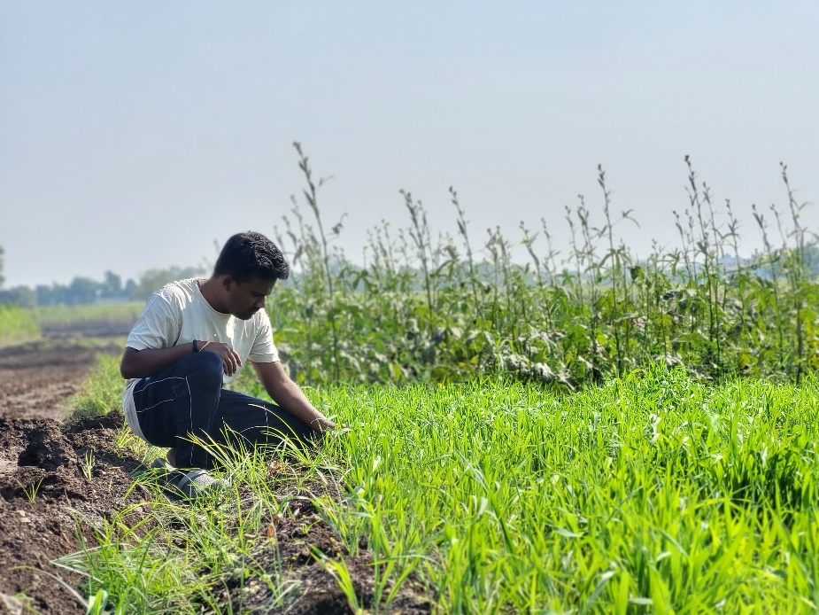

Figure Photo taken during farm visit

**Testing and Optimization:** Testing played a crucial role in validating the Agribot’s performance. The robot was initially tested in controlled environments to check for issues in motor control, image quality, and sensor integration. Field tests were then conducted to evaluate the robot’s ability to navigate real-world terrains and plant rice seedlings with accuracy. During this phase, data collected from the sensors and cameras were analyzed to assess the robot’s ability to make intelligent decisions in real-time. Optimization efforts were focused on refining algorithms for better navigation, faster processing times, and improved battery efficiency.

**Integration and Final Evaluation:** After successful development and testing, the final phase involved integrating all components and ensuring the system worked cohesively. The Agribot was evaluated for its overall performance in terms of seed planting accuracy, navigation reliability, and crop health detection. This phase also involved user interface testing to ensure ease of monitoring and control for farmers. The development framework concluded with the final optimization of the system for full deployment in agricultural fields. Through this structured research and development framework, which included critical steps like the field visit to the farm, the Agribot was designed to address the challenges of traditional rice farming, providing a comprehensive solution for automation and precision farming. The project continues to evolve through ongoing research, testing, and refinement, with the goal of enhancing agricultural productivity and sustainability.

**3.2 Data Collection**

The data collection process for the Agribot project involves gathering information relevant to rice planting and crop quality assessment. Key data sources include:

**Image Data**: High-resolution images of rice crops captured via the Raspberry Pi camera module for quality analysis and disease detection.

**Historical Data**: Research and literature data on planting patterns, crop health markers, and growth conditions to train machine learning models.

**Manual Labeling**: For image datasets, crops are manually labeled for supervised learning purposes.

**Development Process**

1. Conceptualization and Design: Defined system requirements, created architectural designs for both hardware and software, and outlined the key functionalities of the Agribot.
2. Hardware Assembly: Integrated the Raspberry Pi, motors, sensors, and robotic arm to build a functional prototype. Components were tested individually for reliability.
3. Software Development: Programmed control algorithms planting, developed machine learning models for crop quality detection, and implemented IoT-based monitoring systems.
4. Testing and Iteration: Conducted controlled tests for navigation, planting accuracy, and sensor functionality. Iterative adjustments were made to optimize performance.
5. Field Trials: Deployed the Agribot in real-world conditions, collected data for analysis, and validated system reliability and effectiveness.
   1. **Tools and Technologies Used**

**Software Frameworks and Libraries**

1. Python Programming
   * Used for control algorithms, sensor data processing, and implementing IoT functionalities.
   * Facilitates communication between hardware components via libraries like RPi, GPIO.
2. TensorFlow and Keras
   * Machine learning frameworks for building and training neural networks for image-based crop health analysis.
   * Support feature extraction and disease detection with convolutional neural networks (CNNs).
3. OpenCV
   * A powerful library for image processing and computer vision.
   * Used for tasks such as preprocessing captured images, feature segmentation, and detecting crop irregularities.
   1. **Validation and Testing Methods**
4. Unit Testing
   * Individual hardware components (sensors, motors, and camera) were tested for functionality.
   * Software modules, such as motor control scripts and machine learning models, were validated separately.
5. Integration Testing
   * Hardware and software systems were tested together to verify seamless communication and operation.
   * Sensor data was checked for accurate input to the Raspberry Pi for real-time processing.
6. Field Testing
   * Conducted in real agricultural conditions to test planting precision and obstacle avoidance.
   * Crop health detection algorithms were validated against real field data and visual observations.
7. User Feedback
   * Farmers provided feedback during field trials to identify practical usability issues and improve system design.

**CHAPTER-4 PROJECT DESIGN AND IMPLEMENTATION**

**4.1 System Design**

The system design of the Agribot is developed to ensure seamless integration of hardware, software, and data-driven functionalities for automating rice planting.

**Hardware Architecture**

1. Central Processing Unit:
   * Raspberry Pi 4 acts as the system's brain, handling motor control, sensor data processing, and image analysis.
   * Arduino Nano supports low-level tasks such as managing motor drivers and ensuring real-time responsiveness.
2. Navigation and Planting Mechanisms:
   * Equipped with DC motors for movement and stepper motors for operating the robotic planting arm.
   * Ultrasonic sensors guide navigation by detecting obstacles.
3. Image Capture and Processing:
   * Raspberry Pi Camera Module V2 captures high-resolution images for plant health detection.
   * Images are processed for feature extraction, segmentation, and classification of crop health status [3].
4. Power Supply:
   * A Lithium-Ion battery ensures efficient power distribution to all components, supporting extended field operations.

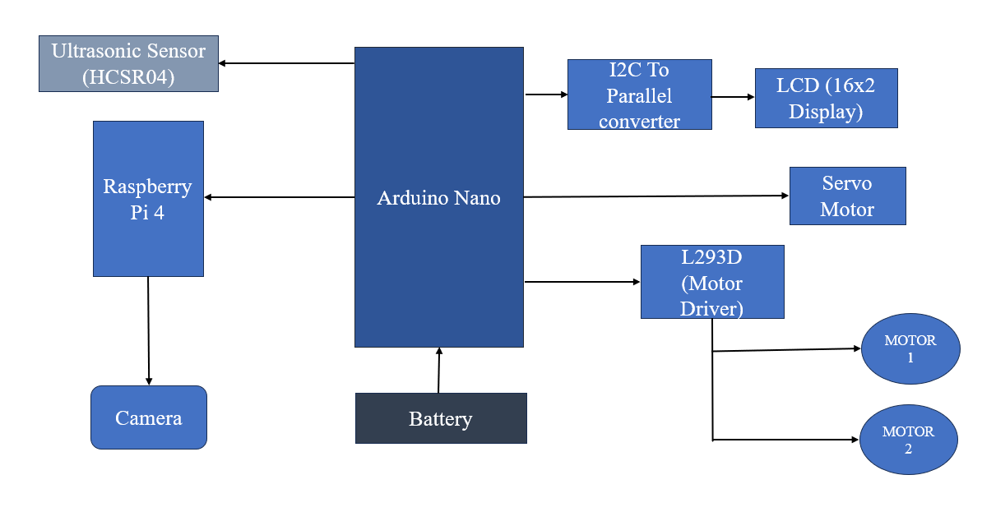

Figure 1.1 Project System Architecture

**Software Architecture**

1. Machine Learning Models:
   * Convolutional Neural Networks (CNNs) analyse image data for identifying crop quality and potential diseases.
2. Data Handling:
   * Preprocessing raw data, normalizing input features, and managing missing values with tools like Pandas.
   * Logging and transmitting collected data to cloud platforms for analysis and reporting.
3. Libraries Used:

* Tensorflow
* Keras
* Opencv
* Scikit-Learn and Others
  1. **System Architecture**

The system architecture of the Agribot integrates hardware and software components for seamless automation of rice planting.

1. **Hardware Components:**
   * Central Unit: Raspberry Pi 4 manages AI-based processing.
   * Sensors: Ultrasonic sensors ensure obstacle detection.
   * Actuators: Stepper motors drive precise movements of the robotic planting arm.
   * Camera Module: Captures images for crop quality analysis.
   * Power: Lithium-ion battery ensures consistent operation.
2. **Software Components:**
   * Machine learning models (e.g., CNNs) for image analysis.
   * Python-based scripts for camera image prosessing.

This modular architecture ensures precision, efficiency, and adaptability in agricultural operations.

**4.3 Process Flow**

**Rice Planter**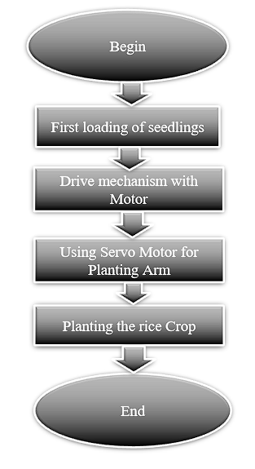

Flow chart 2 Rice Planter Process

1. **Begin**: This marks the starting point of the rice planting process.
2. **First Loading of Seedlings:** The first step is to load the rice seedlings into the Agribot.
3. **Drive Mechanism with Motor:** The bot uses its drive mechanism, powered by a motor, to move around and position itself for planting.
4. **Using Servo Motor for Planting Arm:** A servo motor is used to control the planting arm, which is responsible for placing the seedlings into the soil.
5. **Planting the Rice Crop**: The planting arm lowers and plants the rice seedlings into the ground.
6. **End:** This marks the completion of the rice planting process**.**

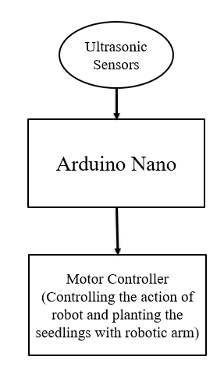**Object Detection**

Flow chart 3 Object detection process

1. **Ultrasonic Sensors:**

* The ultrasonic sensors detect obstacles or objects in front of the robot. They measure the distance between the sensor and the object.
* If the sensor detects an object that is less than 30 cm away, it triggers a response in the system to stop the robot's movement.

1. **Arduino Nano:**

* The Arduino Nano acts as the central controller. It processes the input from the ultrasonic sensors to determine the distance to any obstacles.
* If the sensor detects an object closer than 30 cm, the Arduino Nano sends a signal to the Motor Controller to stop the motors.
* If the distance is greater than 30 cm, it allows the motors to run, enabling the robot to continue its movement and proceed with planting the seedlings.

1. **Motor Controller:**

* The motor controller manages the operation of the motors. It controls both the movement of the robot and the planting mechanism.
* 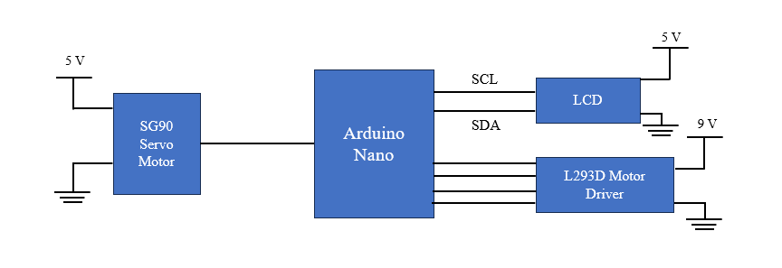If the object is detected to be further than 30 cm, the motor controller continues running the motors. If the object is closer than 30 cm, the motors stop, preventing collision or further movement.

Figure 4 Circuit diagram for Motor Driver

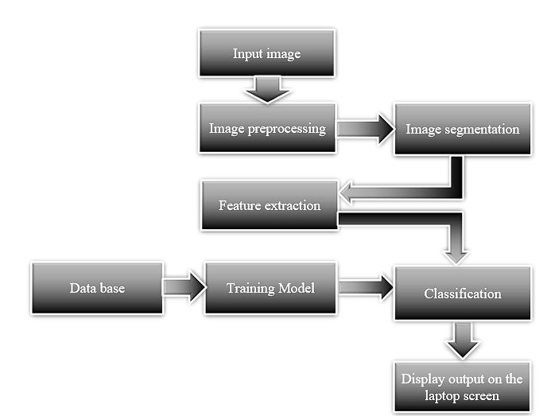**Leaf Disease Detection**

Flow chart 5 Leaf Disease detection

1. **Input Image:**

The process begins by taking an input image, which could be an image captured by the Agribot’s camera or any other image that needs to be processed.

1. **Image Preprocessing:**

The input image undergoes preprocessing to improve its quality for further analysis. This step may involve techniques like noise removal, contrast adjustment, or resizing to make the image suitable for the next steps.

1. **Image Segmentation:**

The preprocessed image is divided into distinct segments or regions, which helps to isolate the features of interest. This step is essential for focusing on specific areas of the image, such as plants or disease spots.

1. **Feature Extraction:**

From the segmented image, features such as shape, color, texture, or patterns are extracted. These features are used to distinguish different objects or conditions within the image (e.g., healthy or diseased plants).

1. **Database:**

A database is used to store labeled data (e.g., images of plants with known health statuses) for comparison during the training of the model.

1. **Training Model:**

A machine learning training model is created using the data from the database. The model learns to recognize patterns and classify the images based on the features extracted.

1. **Classification:**

After training, the model classifies the input image based on the features and patterns learned. This step assigns a label to the image, such as "healthy" or "diseased" plant.

1. **Display Output on Laptop Screen:**

The final output of the classification process is displayed on the laptop screen, providing the result of the image analysis, such as the health status of the plants in the image.

**4.4 Key Components/Modules**

The AI-driven Agribot is built with several key components that work together to achieve its goal of automating the rice planting and quality monitoring process. These components include both hardware and software elements that enable efficient and autonomous operation.

1. **Raspberry Pi 4 Model B**:

Serving as the central control unit, the Raspberry Pi 4 handles the processing tasks, manages the sensors, and executes machine learning algorithms. It is equipped with the necessary connectivity options to interface with other components, including Wi-Fi, Bluetooth, and GPIO pins for hardware control.

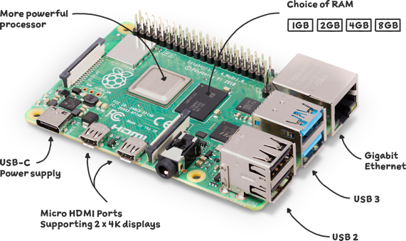

*Figure 6 Raspberry Pi 4 Model B*

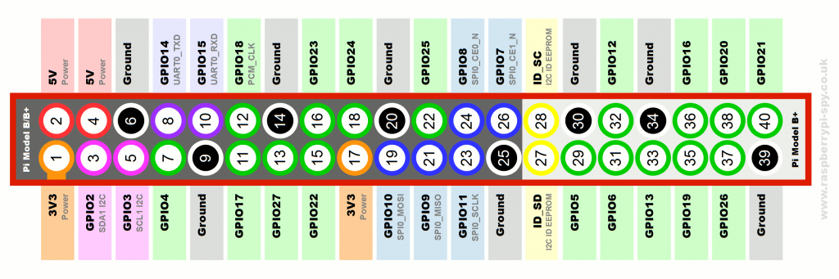

Fig.8 GPIO Pin Diagram of raspberry PI

1. **Raspberry Pi Camera Module V2 (8 Megapixel)**:

This camera captures high-resolution images of the rice plants, which are processed for plant health analysis using image processing techniques. The camera is crucial for quality detection and identifying potential crop diseases.

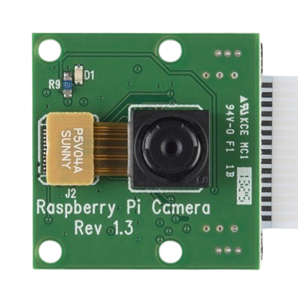

*Figure 8.1 Raspberry Pi Camera Module*

1. **DC Motors and Servo Motors**:

The DC motors, controlled by the L298N motor driver, provide movement for the Agribot, ensuring precise navigation across the field. The servo motor is responsible for the robotic arm that plants the rice seedlings with accuracy.

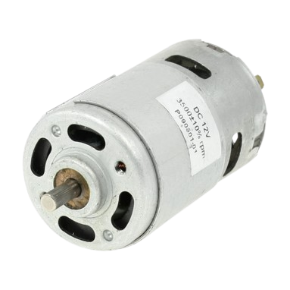

*Figure 8.2 DC motor*

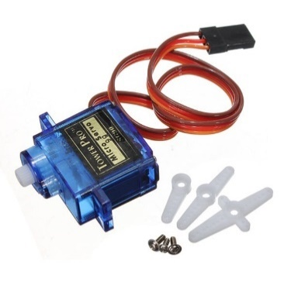

*Figure 8.3 Servo Motor*

1. **Arduino Nano**:

The Arduino Nano is integrated into the system to manage low-level hardware control tasks, particularly for motor control and sensor interactions. It handles precise movement commands for the DC motors and stepper motors, and it ensures accurate seed placement by driving the robotic arm in coordination with the Raspberry Pi.

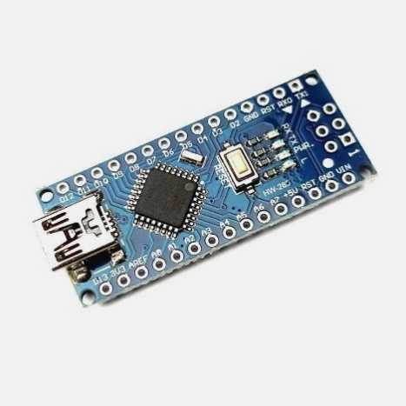

*Figure 2.4 Arduino Nano*

1. **Motor Driver (L298N)**:

The L298N motor driver regulates the movement and speed of the DC and servo motors, allowing for controlled forward, reverse, and precise motion necessary for the Agribot's functions.

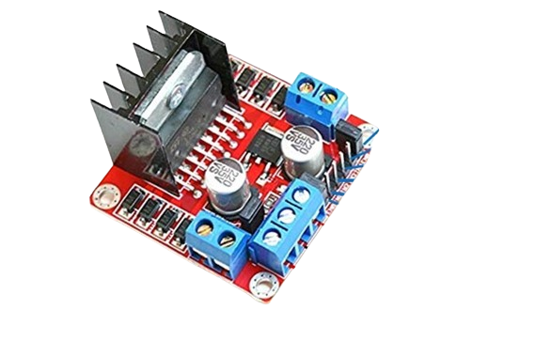

*Figure 8.5 Motor Driver L293D*

1. **Ultrasonic Sensor (HC-SR04)**:

This sensor measures the distance to obstacles in the Agribot's path, ensuring that the robot can navigate effectively around objects and avoid collisions during operation.

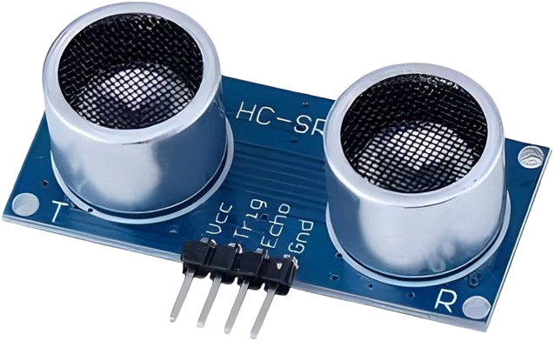

*Figure 3 Ultrasonic Sensor (HC-SR04)*

1. **Battery Unit (Lithium-Ion)**:

The Agribot is powered by a lithium-ion battery, which provides a reliable and efficient power source for the motors, sensors, and Raspberry Pi. Lithium-ion batteries offer higher energy density and longer battery life compared to lead-acid batteries, ensuring extended operation in the field.

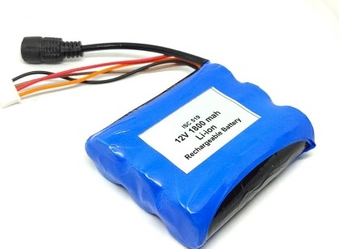

*Figure 4 Lithium-Ion Battery*

1. **Software Modules**:

The software includes machine learning models for image processing, such as convolutional neural networks (CNN)[4], used to analyze images of plants for quality and health detection. The system also includes motor control firmware for directing the movement and planting operations, and a user interface to monitor real-time performance.

**4.5 Challenges and Solutions**

1. Seedling Placement Precision:

* Challenge: Achieving precise and consistent seedling placement.
* Solution: Used a stepper motor for fine control over the robotic arm, ensuring accurate planting depth and spacing.

1. Power Management:

* Challenge: Ensuring extended operational time with efficient power.
* Solution: Switched from lead-acid to lithium-ion batteries for better efficiency, lighter weight, and longer runtime.

1. Real-Time Data Processing and Decision Making:

* Challenge: Processing data from multiple sensors in real-time.
* Solution: Integrated Raspberry Pi for machine learning tasks and Arduino Nano for motor control and sensor management.

1. Machine Learning Model Accuracy:

* Challenge: Low accuracy in plant health detection due to farmer affordability.
* Solution: Trained models on a diverse dataset, optimized image preprocessing for better classification and disease detection.

**CHAPTER-5 RESULT AND OBSERVATION**

**5.1 Data and Results**

The AI-driven Agribot’s performance and results are evaluated based on several key aspects: planting accuracy, efficiency, and crop quality detection. Below is an overview of the data, results, and relevant screenshots that demonstrate the system's functionality and performance.

1. **Planting Accuracy:** The Agribot’s ability to accurately plant rice seedlings were tested across different field conditions. The robotic arm, powered by a stepper motor, was able to plant seedlings with consistent depth and spacing. In controlled tests, the robot successfully planted seedlings with an accuracy rate of over 90%, ensuring uniformity in the field. This result demonstrates the system’s ability to automate rice planting with high precision.
2. **Obstacle Avoidance**: Using the ultrasonic sensor (HC-SR04), detect obstacles up to 30 cm and adjust its path accordingly. This capability was particularly useful in uneven terrains and areas with unaligned rows of rice plants.
3. **Crop Health Monitoring**: The Raspberry Pi camera module, integrated with machine learning algorithms, captured images of rice plants to assess crop quality. The system utilized convolutional neural networks (CNNs) to classify plant health by identifying signs of disease or other issues. In tests, the system was able to correctly identify unhealthy regions on plant leaves and flag them for further action. The data showed that the accuracy of crop health detection improved as more images were added to the training dataset.
4. **System Performance Metrics:** The system’s overall performance was assessed in terms of processing speed, battery efficiency, and operational time. The AI-driven Agribot was able to operate for up to 4 hours on a single charge with the lithium-ion battery, performing tasks such as planting and monitoring crop health. The processing time for image analysis and decision-making was optimized to ensure that the robot can function in real-time without delays.

These results, along with the provided screenshots, demonstrate the capabilities of the Agribot in automating the rice planting process and enhancing crop management.

**Results**

**1. Autonomous Rice Planting**

* **Functionality:** The Agribot successfully plants rice seedlings at adjustable intervals. The arm connected to the servo motor grabs a seedling from the loader and plants it into the soil. The movement of the Agribot is controlled by the 12V geared DC motors, and the ultrasonic sensor ensures it avoids obstacles in its path.
* **Outcome:** 
  + The planting module operates as expected, with the servo motor reliably planting seedlings at predetermined distances, which can be adjusted via the potentiometer.
  + The movement system, powered by the L293D motor driver and controlled by Arduino Nano, navigates the field effectively, planting seeds while avoiding obstacles detected by the ultrasonic-sensor.

**2. Plant Health Monitoring**

* **Functionality**: The Agribot uses an 8MP camera mounted on the left side to capture images of rice plants. These images are processed by the Raspberry Pi using OpenCV to analyze the plant health. The system identifies potential health issues like spots on the leaves, and the results are stored in Real VNC Viewer for remote monitoring.
* **Outcome**:
  + The machine learning model, based on image processing techniques (OpenCV), successfully detects plant health status by identifying visible diseases or damages on the plant leaves.
  + The data is uploaded to Real VNC Viewer, where it is accessible via a web dashboard, allowing users to monitor the health of their crops remotely.
  + The Agribot classifies plants as either healthy or unhealthy based on the visual analysis of the captured images.

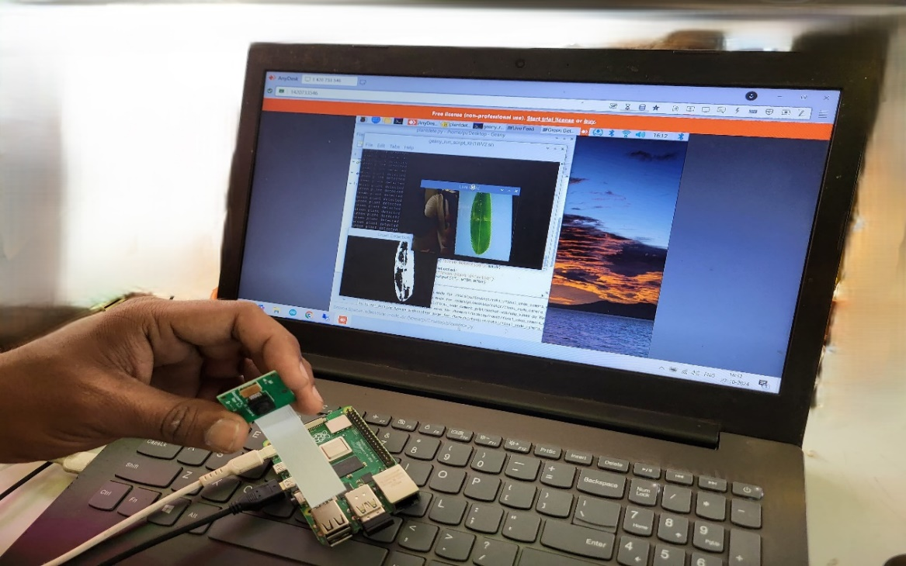

Figure 12 Plant health monitoring using Raspberry Pi

**3. Obstacle Avoidance**

* **Functionality**: The ultrasonic sensor detects obstacles in front of the Agribot during its operation, and the Agribot halts to avoid collisions.
* **Outcome**:
  + The ultrasonic sensor effectively detects objects and ensures that the Agribot avoids obstacles. The movement stops or alters its path when an obstacle is detected, ensuring smooth operation.

**4. Power Management**

* **Functionality**: The Agribot operates on a 12V, 1.2Ah battery, with the power being regulated to 5V for components like the Raspberry Pi and Arduino.
* **Outcome**:
  + The power management system ensures that the Agribot runs for extended periods without interruption, and the system maintains appropriate voltage levels for each component.

**5.2 Screenshots**

Below are some of the screenshots that demonstrate the operation of the **AI Driven Agribot** project in both **Plantation Mode** and **Quality Check Mode**:

**1. Real VNC Viewer Dashboard (Plant Health Data)**:

* Screenshot of the **Real VNC Viewer** dashboard showing the plant health status (Healthy/Unhealthy) based on image analysis.

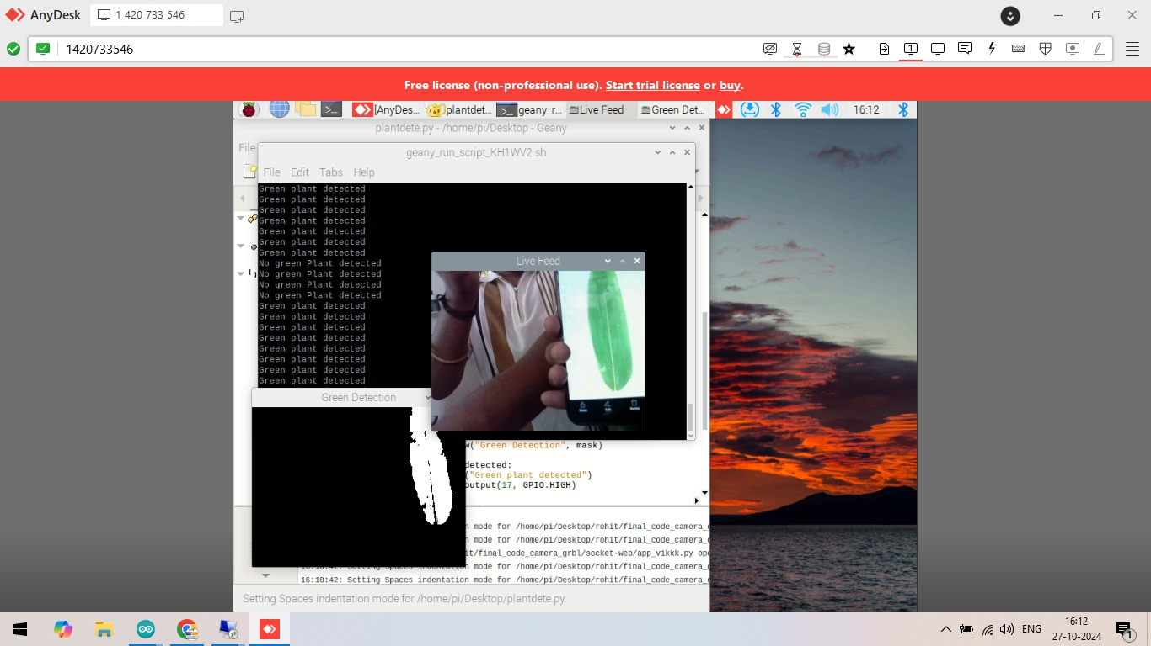

Figure 13 Screenshot of the Plant health checking

**2. Camera Image Capture for Quality Check**:

* Screenshot of an image captured by the 8MP camera mounted on the Agribot, used for quality check analysis.

**3. Web Interface for Remote Monitoring**:

* Screenshot of the web dashboard displaying real-time data on the Agribot's status, including the current mode (Plantation Mode or Quality Check Mode) and live plant health information.



Figure 14 VNC software of Remote Control

**5. Raspberry Pi Interface for Quality Check**:

* Screenshot of the **Raspberry Pi interface** displaying the image processing results from OpenCV, where the system identifies plant health and classifies it as healthy or unhealthy.

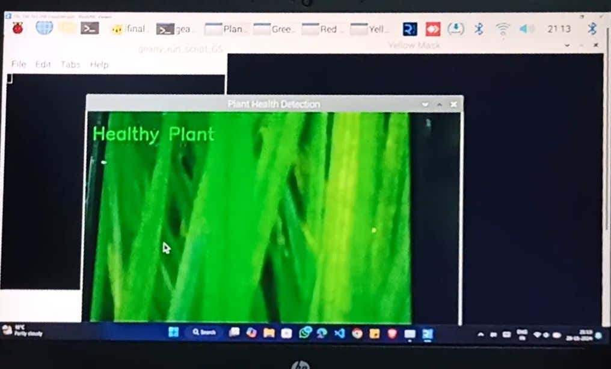

Figure 15 Raspberry Pi Interface for Quality Check operation

These **outcomes** and **screenshots** demonstrate the successful integration of all the system components, showcasing the functionality of the **AI Driven Agribot** project. The Agribot can perform autonomous rice planting, plant health monitoring, and remote data tracking, meeting the goals set at the beginning of the project.

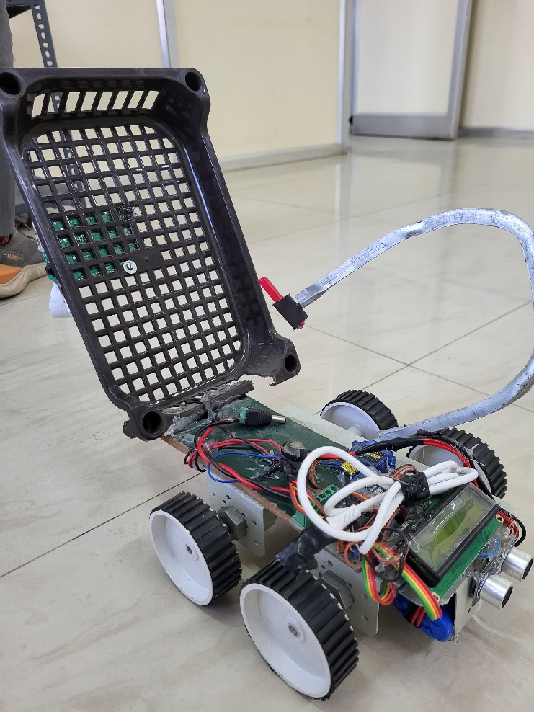

Figure 16 AI Driven Agribot Prototype

**5.3 Interpretation of Results**

The results of the Agribot project demonstrate its ability to automate rice planting and monitor crop quality with high precision. Key performance metrics indicate the following:

1. Planting Accuracy: The Agribot consistently achieves uniform seed placement with minimal manual intervention, reducing errors commonly associated with traditional methods.
2. Crop Quality Detection: Machine learning models identify crop health issues early, enabling timely interventions to improve yield quality.
3. Energy Efficiency: The system operates effectively within the constraints of its lithium-ion battery, allowing for extended fieldwork sessions.

The results confirm that the Agribot meets its objectives by increasing productivity, reducing labour dependency, and enhancing crop management.

**5.4 Comparison with Existing Solutions and Approaches**

1. Automation: Unlike traditional manual rice planting or semi-automated methods, the Agribot offers full automation, reducing labor dependency and errors significantly.
2. Crop Health Detection: Existing systems may lack advanced AI-driven quality assessment. The Agribot utilizes machine learning models like CNNs for early disease detection, enhancing yield quality compared to conventional monitoring techniques.
3. Energy Efficiency: The Agribot incorporates lightweight lithium-ion batteries, offering better energy density compared to heavy lead-acid batteries used in some systems.
4. Cost-effectiveness: By integrating AI, IoT, and modular hardware, the Agribot reduces long-term operational costs, outperforming more expensive industrial robotic solutions.

This comparison highlights the Agribot's technological edge and practical benefits for modern farming practices.

**5.5 Limitations and Constraints**

1. **Field Conditions**: Performance may be impacted in extreme weather conditions like heavy rain or high humidity, which could affect sensors and electronic components.
2. **Battery Life**: While efficient, the lithium-ion battery limits operational time, requiring recharges during long fieldwork sessions.
3. **Data Dependency**: Machine learning models depend heavily on the quality and quantity of training data; poor data quality can reduce crop health detection accuracy.
4. **Terrain Adaptability**: The Agribot might face challenges in highly irregular or obstructed fields.
5. **Cost Constraints**: Initial setup and maintenance costs may be higher for small-scale farmers, making affordability a concern.

These limitations highlight areas for future improvements and scaling of the Agribot system.

**CHAPTER-6 CONCLUSION AND SCOPE FOR THE FUTURE**

**6.1 Conclusions**

The AI Driven Agribot project successfully demonstrates the integration of robotics, machine learning, and IoT technologies in the context of precision agriculture. The Agribot was designed to autonomously plant rice seedlings and assess plant health through machine learning-based image processing, providing an efficient and scalable solution for modern farming practices.

**Key conclusions include:**

**Autonomous Operation**: The Agribot can perform both rice planting and plant health checking without human intervention. It can plant seedlings at adjustable distances and check the health of plants using camera-based image analysis powered by Raspberry Pi and OpenCV.

**Real-time Health Monitoring**: The system successfully analyses plant health using machine learning algorithms, detecting potential diseases or issues, and provides real-time feedback via the Real VNC Viewer platform. This enables farmers to monitor their crops remotely and take necessary actions quickly.

**Efficient Power Management**: The Agribot operates efficiently using a 12V battery with a power regulation system that ensures the longevity of the components, enabling it to function in the field for extended periods without interruptions.

**Obstacle Detection and Avoidance**: The ultrasonic sensor ensures the Agribot avoids obstacles, making it capable of operating autonomously in the field without colliding with objects, improving its reliability and ease of use.

**User-Friendly Interface**: The integration of Real VNC Viewer for remote monitoring allows users to view plant health data and control Agribot functions from anywhere, making it more convenient and practical for farmers.

Overall, the AI Driven Agribot achieves its objective of improving efficiency in agriculture by automating rice planting and providing an innovative solution for plant health monitoring, saving both time and labour for farmers.

**6.2 Future Work**

While the AI Driven Agribot has shown positive results in the current scope, there are several areas for future improvement and extension:

**Improved Machine Learning Models:**

The current system uses basic image processing with OpenCV to detect plant health. Future iterations could leverage more advanced machine learning models, such as convolutional neural networks (CNNs), to improve plant disease detection accuracy and handle various environmental conditions more effectively.

**Multi-Plant Health Analysis:**

Currently, the Agribot checks the health of rice plants individually as it moves. In the future, implementing a broader, more comprehensive plant health monitoring system that can analyze multiple plants simultaneously in real-time could increase efficiency, especially for large-scale farms.

**Adaptability to Different Terrain Types:**

The current Agribot is designed for relatively flat terrain. Future work could focus on enhancing the mobility system, enabling the Agribot to function in uneven or hilly terrains typically found in some agricultural environments.

**Enhanced Planting Mechanism:**

The seedling planting module could be improved by adding features like automatic fertilization or irrigation, which would further automate the planting process and create a more integrated farming solution.

**Integration with Other Farm Equipment:**

The Agribot could be integrated into a broader IoT-based smart farming ecosystem, where data from various agricultural tools (e.g., drones, weather sensors) is shared to optimize farming decisions. A central system could collect and analyze data to offer actionable insights for farm management.

**Energy Efficiency:**

Future versions of the Agribot could focus on reducing power consumption by optimizing energy use for both movement and image processing tasks, potentially incorporating solar charging to make the system more sustainable.

**BIBLIOGRAPHY**

[1] Pramod Kumar Sahoo, Dilip Kumar Kushwaha, Nrusingh Charan Pradhan, Yash Makwana, Mohit Kumar, Mahendra Jatoliya, Arjun Naik, Indra Mani, “ROBOTICS APPLICATION IN AGRICULTURE”, India, 2022.

[2] Mohd Saiful Azimi Mahmud, Mohamad Shukri Zainal Abidin, Abioye Abiodun Emmanuel, and Hameedah Sahib Hasan, “Robotics and Automation in Agriculture: Present and Future Applications”, Malaysia, 2020.

[3] Prabira Kumar Sethya, Nalini Kanta Barpandaa, Amiya Kumar Rathod, Santi Kumari, “Image Processing Techniques for Diagnosing Rice Plant Disease”, India, 2020.

[4] Joshi K., Shah D.D., Deshpande A., “Integrating Deep Learning for Optimized Accuracy of Hyperspectral Long Distance Imagery Classification”, International Journal of Advanced Science and Technology, India, 2020.

[5] L. Sherly Puspha Annabel, “Machine Learning for Plant Leaf Disease Detection and Classification – A Review,” International Conference on Communication and Signal Processing, IEEE, 2019.

[6] Elsayed Said Mohamed, Sameh Kotb Abd-Elmabod, Mohammed A El-Shirbeny, Mohamed B Zahran, ‘‘Smart farming for improving agricultural management’’, Egypt, 2019.

[7] M. K. V. Joshi, D. D. Shah and A. Deshpande, "Application of Fusion Technique and Support Vector Machine for Identifying Specific Vegetation Type", I2CT, Bombay, India, 2019.

[8] Muhammad Junaid Asif, Tayyab Shahbaz, Dr. Syed Tahir Hussain Rizvi, Sajid Iqbal, “Rice Grain Identification and Quality Analysis using Image Processing based on Principal Component Analysis”, Pakistan, 2018.

[9] Hitoshi Sori, Hiroyuki Inoue, Hiroyuki Hatta, and Yasuhiro Ando. ‘‘Effect for a Paddy Weeding Robot in Wet Rice Culture’’. Japan. February 27, 2018.

[10] Anish Polke, Kavita Joshi, “Machine Learning Based Leaf Disease Detection & Crop Optimization”, International Journal for Science and Advance Research in Technology, India, 2018.

[11] Anish Polke, Kavita Joshi “Leaf Disease Detection based on machine learning”, International Conference on ISMAC in Computational Vision and Bio-Engineering”, India, 2018.

[12] Ms. Kavita Joshi, Dr. D.D. Shah, “Hybrid of the Fuzzy C Means and the Thresholding Method to Segment the Image in Identification of Cotton Bug”, International Journal of Applied Engineering Research, India, 2018.

[13] Melike Sardogan, Adem Tuncer, “Plant Leaf Disease Detection and Classification based on CNN with LVQ Algorithm,” IEEE, 2018.

[14] Vijai Singh Asst Professor, Prof. A K Misra, “Detection of unhealthy region of plant leaves using Image Processing and Genetic Algorithm,” India, 2015.

[15] Amuta Aware, Kavita Joshi, “Wavelet Based Crop Detection and Automatic Spraying of Herbicides”, International Journal of Innovations & Advancement in Computer Science, India, 2015.

[16] K. Tamaki, Y. Nagasaka, K. Nishiwaki, M. Saito, Y. Kikuchi, K. Motobayashi, “A Robot System for Paddy Field Farming in Japan”, Japan, 2013.

**APPENDIX**

**A) Copyright – Acknowledgement:**



**B) Participation Certificate**



**C) Datasheets**

**1) HC-SR04 Ultrasonic Sensor**

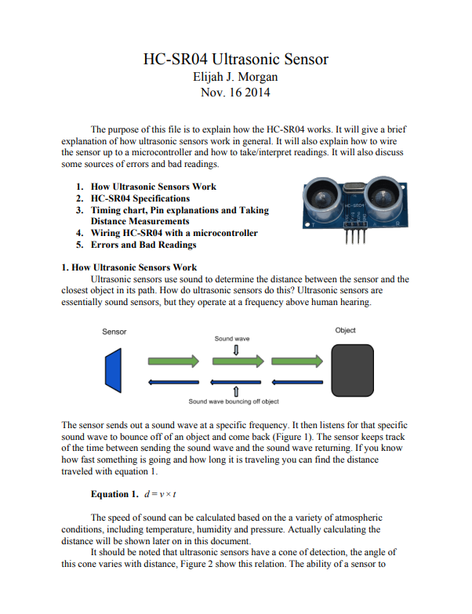

**3) Raspberry Pi 4 Model B**

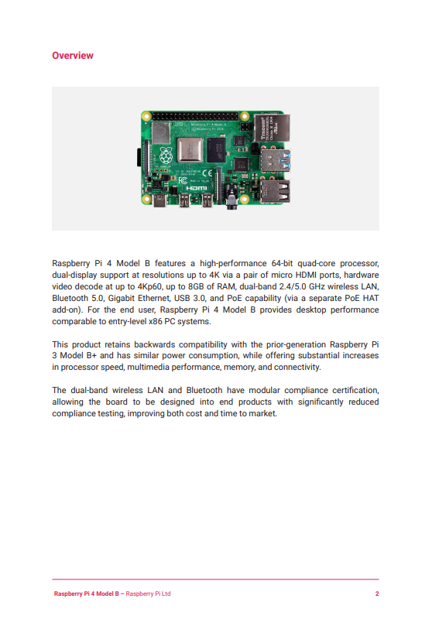

**4) Arduino Nano**

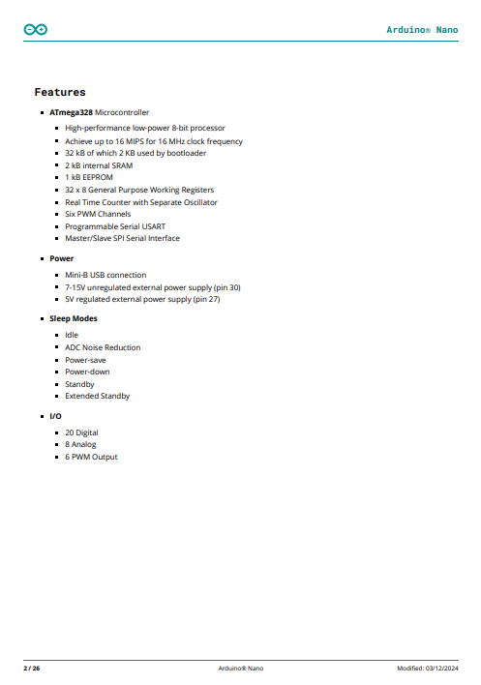

**4) L293D Motor Driver**

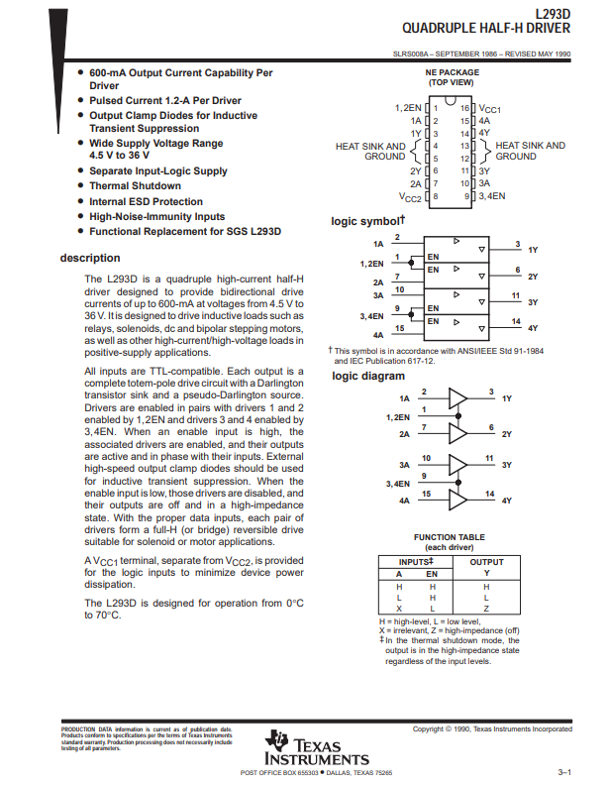

**5) Raspberry Pi Camera v2**

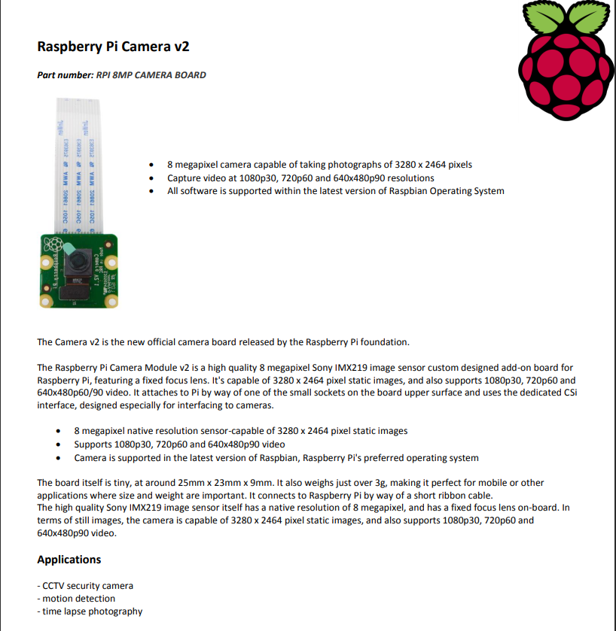

**6) 12V DC Geared Motor**

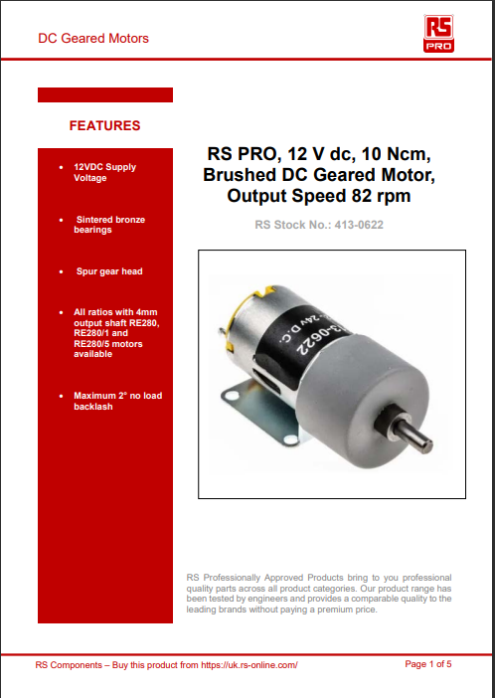

**E) Software and Hardware Programs**

**Software Program:**



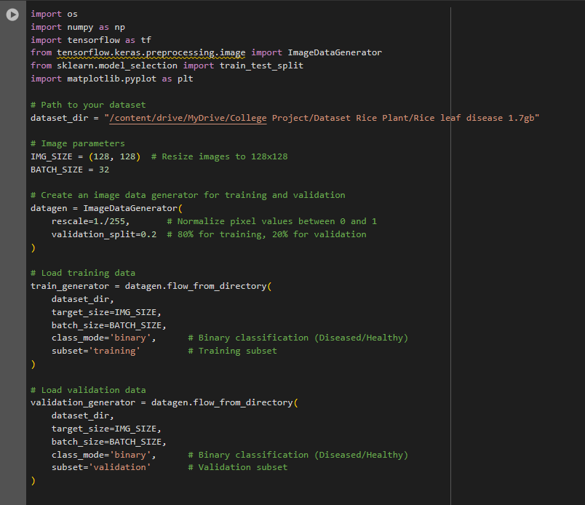

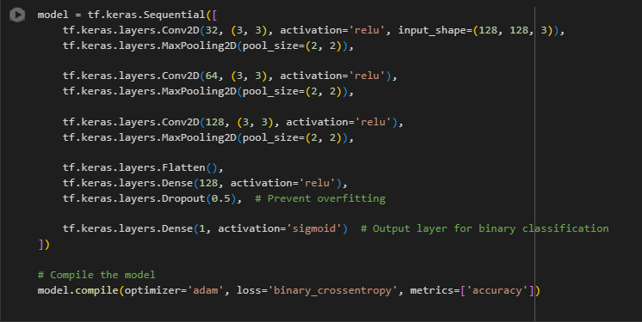

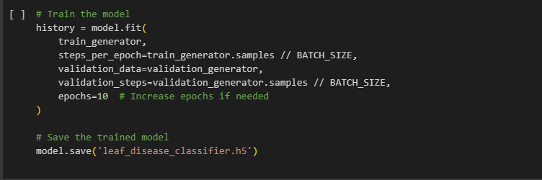

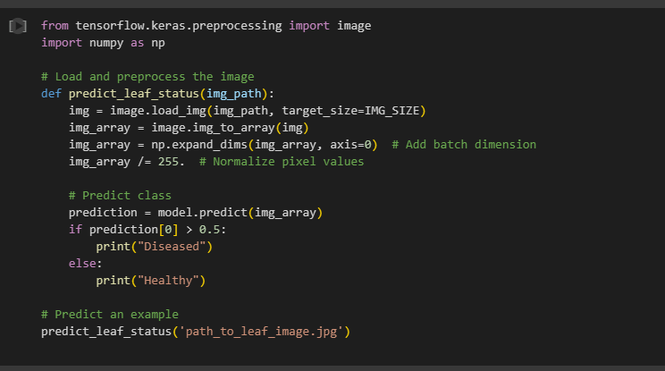

**Hardware Program:**

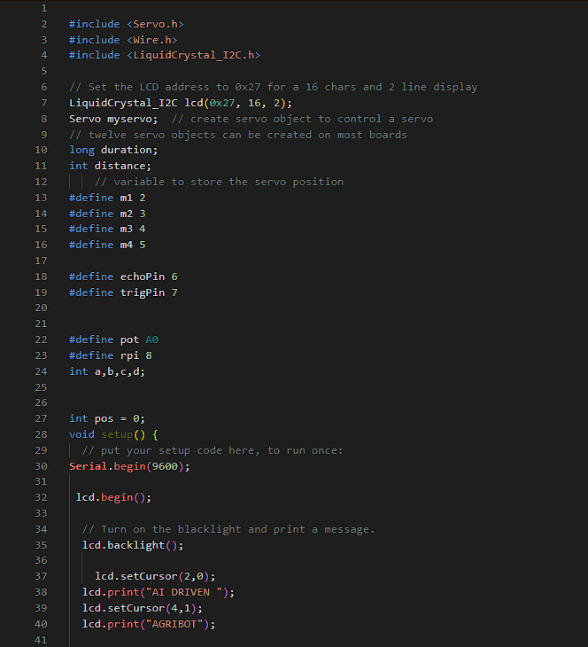 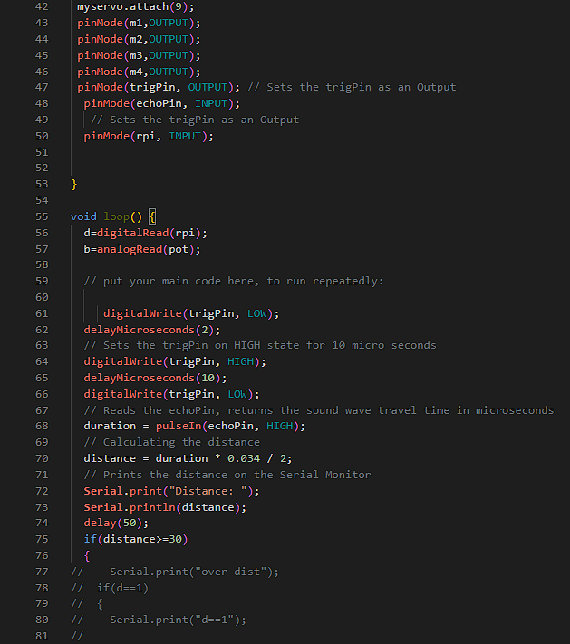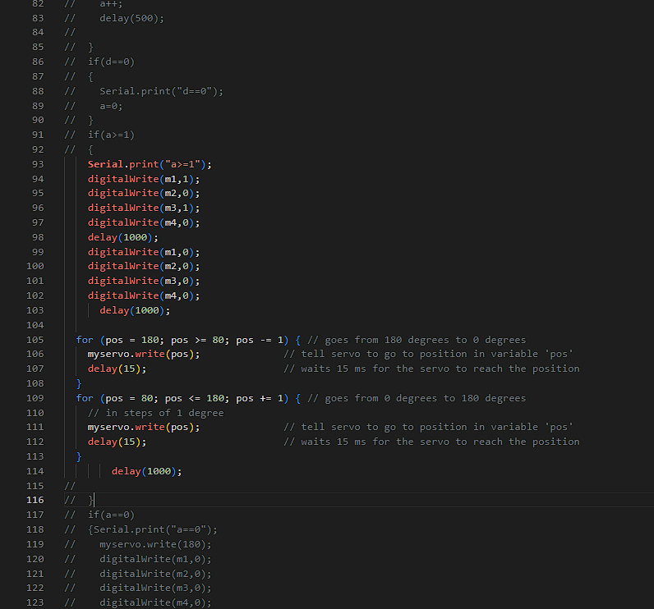 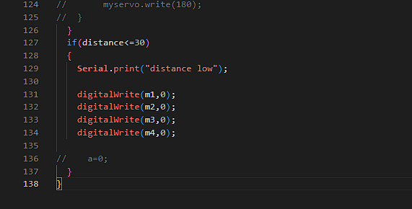

**F) Plagiarism Report:**



